Saga Pattern in Microservices
A microservice-based application is a distributed system. The overall system consists of multiple smaller services, and together these services provide the overall application functionality. One of the major problems in a microservice architecture is how to handle a transaction that spans multiple services.
Database per Service Pattern
One of the benefits of microservice architecture is that we can choose the technology stack per service.
For instance, we can decide to use a relational database for service A and a NoSQL database for service B.
Distributed Transaction
We’ll take an example of an e-commerce application that processes online orders and is implemented with microservice architecture.
There is a microservice to create the orders, one that processes the payment, another that updates the inventory and the last one that delivers the order.
Each of these microservices performs a local transaction to implement the individual functionalities:
This is an example of a distributed transaction as the transaction boundary crosses multiple services and databases.
To ensure a successful order processing service, all four microservices must complete the individual local transactions. If any of the microservices fail to complete its local transaction, all the completed preceding transactions should roll back to ensure data integrity.
Challenges of Distributed Transaction
We provided a real-life example of a distributed transaction. Distributed transactions in microservice architecture pose two key challenges.

The first challenge is maintaining ACID : To ensure the correctness of a transaction, it must be Atomic, Consistent, Isolated and Durable (ACID). The atomicity ensures that all or none of the steps of a transaction should complete. Consistency takes data from one valid state to another valid state. Isolation guarantees that concurrent transactions should produce the same result that sequentially transactions would have produced. Lastly, durability means that committed transactions remain committed irrespective of any type of system failure. In a distributed transaction scenario, as the transaction spans several services, ensuring ACID always remains key.
The second challenge is managing the transaction isolation level.

Understanding Two-Phase Commit
The Two-Phase Commit protocol (2PC) is a widely used pattern to implement distributed transactions. We can use this pattern in a microservice architecture to implement distributed transactions.
In a two-phase commit protocol, there is a coordinator component that is responsible for controlling the transaction and contains the logic to manage the transaction.
- Prepare Phase – The coordinator asks the participating nodes whether they are ready to commit the transaction. The participants returned with a yes or no.
- Commit Phase – If all the participating nodes respond affirmatively in phase 1, the coordinator asks all of them to commit. If at least one node returns negative, the coordinator asks all participants to roll back their local transactions.

Problems With 2PC
2PC is useful to implement a distributed transaction
- All other services need to wait until the slowest service finishes its confirmation. So, the overall performance of the transaction is bound by the slowest service.
- The two-phase commit protocol is slow by design due to the chattiness and dependency on the coordinator. So, it can lead to scalability and performance issues in a microservice-based architecture involving multiple services.
- Two-phase commit protocol is not supported in NoSQL databases. Therefore, in a microservice architecture where one or more services use NoSQL databases, we can’t apply a two-phase commit.

What Is Saga Architecture Pattern?
The Saga architecture pattern provides transaction management using a sequence of local transactions.
A compensating transaction must be idempotent and retryable. These two principles ensure that we can manage transactions without any manual intervention.
The Saga Execution Coordinator (SEC) guarantees these principles:
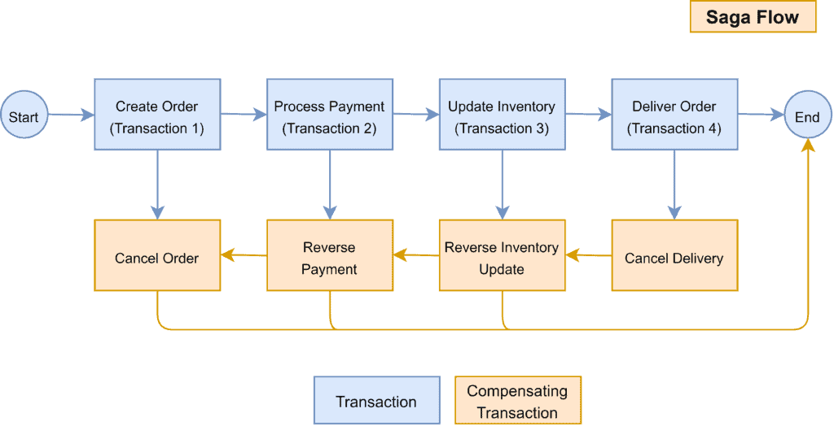

The Saga Execution Coordinator
The Saga Execution Coordinator is the central component to implement a Saga flow. It contains a Saga log that captures the sequence of events of a distributed transaction.
For any failure, the SEC component inspects the Saga log to identify the impacted components and the sequence in which the compensating transactions should run.
For any failure in the SEC component, it can read the Saga log once it’s coming back up.
It can then identify the transactions successfully rolled back, which ones are pending, and can take appropriate actions:
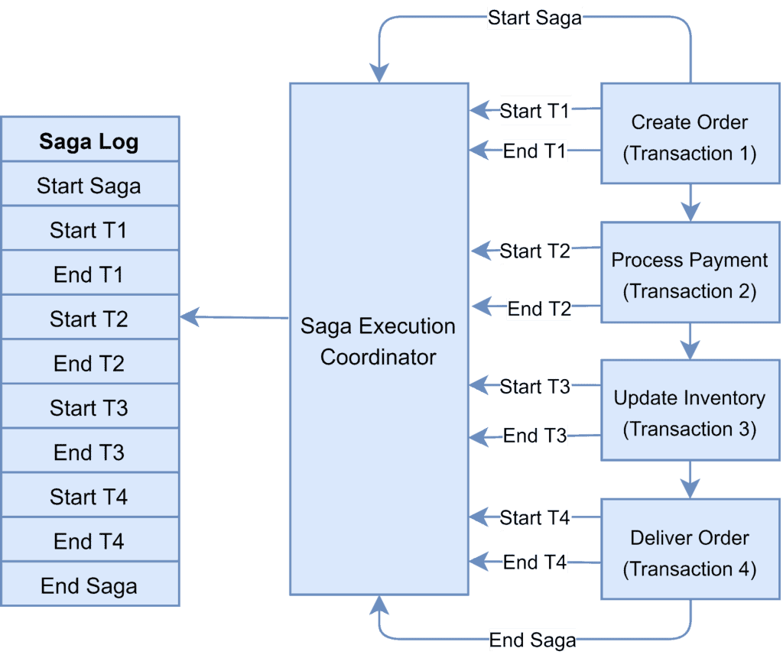
There are two approaches to implement the Saga pattern: choreography and orchestration. Let’s discuss them in the next sections.

Choreography Pattern
Each microservice that is part of the transaction publishes an event that is processed by the next microservice.
the Saga Execution Coordinator is either embedded within the microservice or can be a standalone component.
Choreography flow is successful if all the microservices complete their local transaction, and none of the microservices reported any failure.
The following diagram demonstrates the successful Saga flow for the online order processing application:
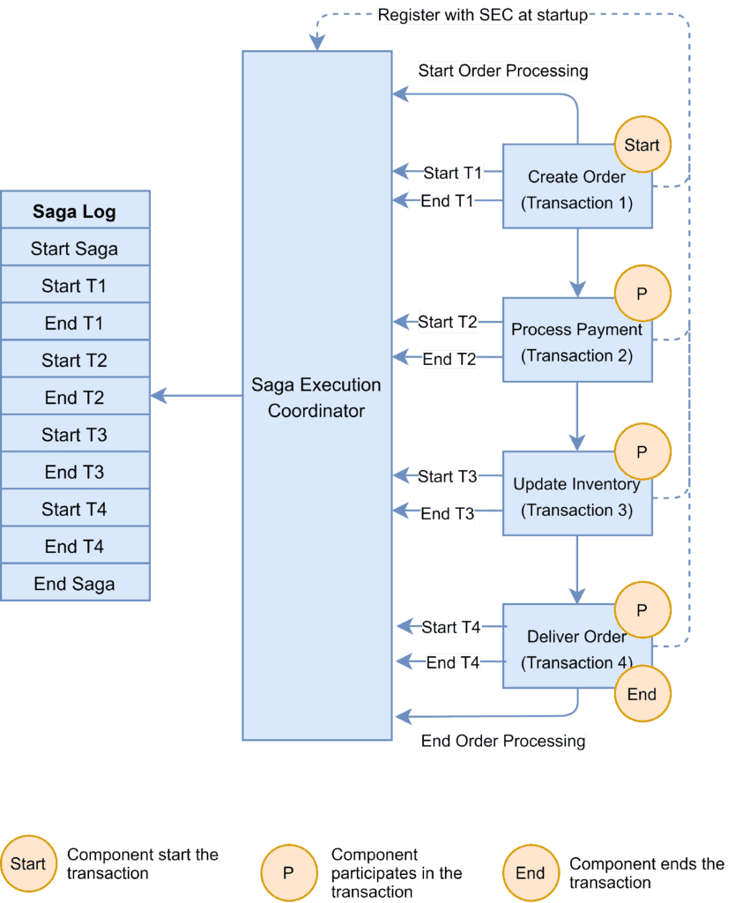
In the event of a failure, the microservice reports the failure to SEC, and it is the SEC’s responsibility to invoke the relevant compensation transactions:
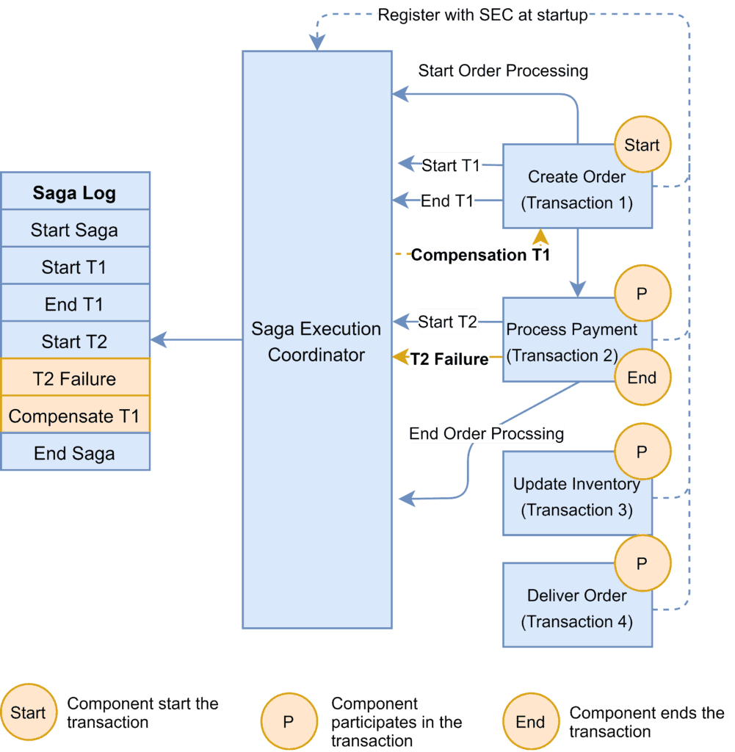
In this example, the Payment microservice reports a failure, and the SEC invokes the compensating transaction to unblock the seat. If the call to the compensating transaction fails, it is the SEC’s responsibility to retry it until it is successfully completed. Recall that in Saga, a compensating transaction must be idempotent and retryable.
The Choreography pattern works for greenfield microservice application development.
- Axon Saga – a lightweight framework and widely used with Spring Boot-based microservices

Saga Orchestration Pattern.
A single orchestrator is responsible for managing the overall transaction status.
If any of the microservices encounter a failure, the orchestrator is responsible for invoking the necessary compensating transactions:
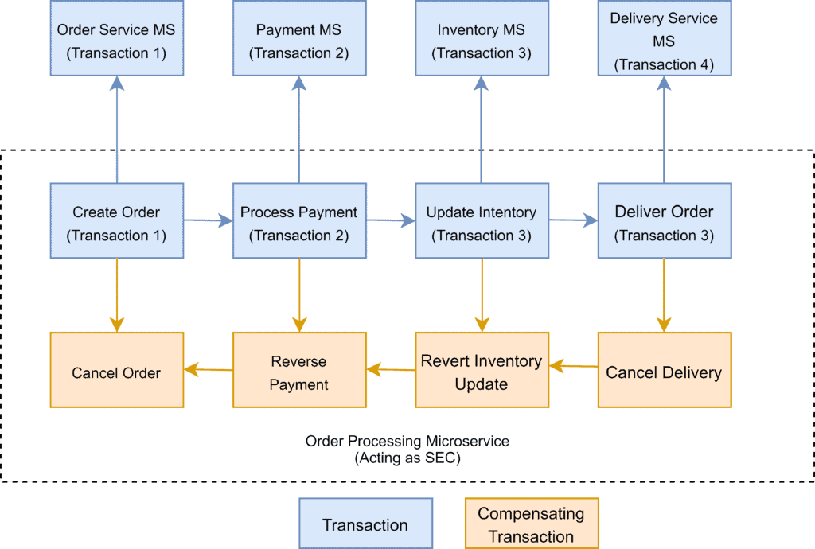

Saga orchestration pattern is useful for brownfield microservice application development architecture.
- Camunda is a Java-based framework that supports Business Process Model and Notation (BPMN) standard for workflow and process automation.
- Apache Camel provides the implementation for Saga Enterprise Integration Pattern (EIP).

